|  |  |  |  |  |  |  |  |
| --- | --- | --- | --- | --- | --- | --- | --- |
| USED ON: | | C07930 - COMPUTER ASSY, EMBEDED, OS & APPS, VI-CELL BLU | | | | | |
| LOCATION: | | INDIANAPOLIS | | | | | |
| ORIGINAL APPROVALS | | | | | | | |
| HANDWRITTEN | | | | TYPED | | | DATE (YY-MM-DD) |
| DWN | | | | **N. BAKER** | | |  |
| CHKR | | | | **R. HINNARD** | | |  |
| PCE | | | | **B. WIDDIFIELD** | | |  |
| QA | | | | **S. CROUCH** | | |  |
| ENGR | | | | **T. DIAZ** | | |  |
| MFG | | | | **K. ADAMS** | | |  |
| APPD | | | | **V. LAMBERT** | | |  |
| CHANGES | | | | | | | |
| *REVISION* | *C.O. NO.* | | *DATE (YY-MM-DD)* | | *CHANGED BY* | *CHECKED BY* | |
| **AA** |  | |  | |  |  | |
|  |  | |  | |  |  | |
|  |  | |  | |  |  | |
|  |  | |  | |  |  | |
|  |  | |  | |  |  | |
|  |  | |  | |  |  | |
|  |  | |  | |  |  | |
|  |  | |  | |  |  | |
|  |  | |  | |  |  | |
|  | | | | | | | |
| **THIS IS A PRODUCT COMPLIANCE ENGINEERING (PCE) IMPACT PART RELATED TO ELECTROMAGNETIC COMPATIBILITY (EMC) AND / OR PRODUCT SAFETY.**  **ALL CHANGES MUST BE REVIEWED BY Q.A. AND PCE.** | | | | | | | |
|  | | | | | | | |
| SEE SITE-SANCTIONED DOCUMENT CONTROL SYSTEM FOR GENERAL PURPOSE STANDARD OPERATING PROCEDURES. | | | | | | | |
| *THIS DOCUMENT CONTAINS PROPRIETARY INFORMATION OF BECKMAN COULTER, INC. AND IS TENDERED SUBJECT TO THE CONDITIONS THAT THE INFORMATION  (A) BE RETAINED IN CONFIDENCE (B) NOT BE REPRODUCED OR COPIED IN WHOLE OR IN PART AND (C) NOT BE USED OR INCORPORATED IN ANY PRODUCT,  EXCEPT UNDER AN EXPRESS WRITTEN AGREEMENT WITH BECKMAN COULTER, INC.* | | | | | | | |

**BILL OF MATERIALS**

| ***PART NUMBER*** | ***DESCRIPTION*** | ***QTY*** | ***REF. DES.*** |
| --- | --- | --- | --- |
| C08365 | Application Set Assembly, Vi-CELL BLU | 1 |  |
| C08360 | Hard Drive Assy, SSD, 500GB | 1 |  |
| C08363 | OS Image Specification, Vi-CELL BLU FL | 1 |  |

**NOTES:**

| **Item** | **Description** | **Additional Information** |
| --- | --- | --- |
| 1 | C08358 – See C08358 specification document | This is the base hard drive assembly with OS, apps & drivers. |
| 2 | C08365 - Application Set Assembly, Vi-CELL BLU | Controlled under C24940 Program Tree |
| 3 | Serial Number:  Each hard drive assembly must be uniquely serialized. This serial number may be the OEM serial number. | Vendor Specified. |
| 4 | Warranty:  None. | Beckman Coulter does not require a warranty on the hard drive assembly. |
| 5 | Label - Package Label  Label to Include:   1. Beckman Coulter Logo 2. Internal P/N: C08356 3. Description:   Drive assembly, with OS & instrument Apps, Vi-CELL BLU   1. Qty: 1 2. Serial Number   Date of Manufacture | Vendor specified and supplied.  Additional items that may appear on the label include any legal or regulatory required symbols or wording, e.g. WEEE, cRoHS, etc.  Label may be printed monochrome if color is not available.  If combined with the HIBC label, the Date of Manufacture does not need to be duplicated.  Requirements for this label may be changed by Beckman Coulter without the need to revise this specification document. |
| 6 | HIBC Label for packaged product:   1. Beckman Coulter Logo and Name 2. PN symbol: C08356 3. SN symbol: Serial Number 4. REF symbol: Vendor part number reference 5. Mfg Date Symbol: Assy. Mfg Date (not OEM manufacturing date) 6. Rev: xx BCI revision as appropriate 7. Qty: indicates the quantity in the shipping package. Shipping package may contain multiple articles, provided internal packaging contains only a single assembly per package, and each single-assembly package provides the expected labelling. 8. Primary HIBC barcode (Hxxx, C08356) 9. Human readable code 10. Secondary HIBC barcode (Serial Number) 11. Human readable code 12. Include Any Required Symbols   Printed in USA | Vendor Specified and Supplied but meeting the requirements outlined in the “UPN Memo to Suppliers” available from Beckman Coulter.  Description may be shortened to occupy only one line.  Additional items that may appear on the label include any legal or regulatory required symbols or wording, e.g. WEEE, cRoHS, etc.  This label may be combined with the package label in 12 or applied as a separate label.  Requirements for this label may be changed by Beckman Coulter without the need to revise this specification document. |

# 

# Hard Drive Software Installations

The following are the software installations to be applied to the base hard drive assembly, and the minimum verifications for performance. Performance verification may be performed on a sample created using the reference image, attached to a test fixture or sample of the target computer assembly.

## Operating system Installation

1. The base operating system image from BEC is contained in BEC part number C08363 “Win10 IoT OS image w/ drivers, Vi-CELL Instrument”.
   1. The OS image on the reference media is supplied as a set of uncompressed files.
   2. The files from the reference media must be transferred to the installation media.
   3. The installation media may be used for multiple installations, but should be checked periodically against the files from the reference image, if the installation media is not write-protected.
2. Attach the base hard drive to a target computer assembly.
3. Apply the base operating system image from BEC part number C08363 to the hard drive, P/N C08360 “Hard Drive Assy, SSD, 500GB”.
4. Ensure that the target computer assembly is not connected to a network, or have internet access.
5. Restart the computer, booting from the imaged hard disk, and verify that the operating system boots, performs an auto-login, and displays a sparse desktop.
6. Using the network configuration utilities, confirm that the LAN1 network interface port is enabled, and configured to use DHCP. Confirm that the LAN2 port is disabled (if listed).
7. Hard drive now represents the C08358 part number.

## Application Software Installation

1. The instrument application software is contained in BEC part number C08365 – Application Set Assy, Vi-CELL BLU. The application software is supplied on a USB drive, BEC P/N C10358. This P/N contains the application set installer binary object representing P/N C08365. The application installer file name may contain a version number reference embedded in the file name.
   1. The application software image on the reference media is supplied as a single compressed, self-extracting file.
   2. Installation media must be a USB flash drive.
   3. If the installation media is used for multiple installations and is not write-protected, it should be checked periodically against the reference image.
2. Apply the application software installation to the system drive using the following steps:
   1. Reboot/restart the system. The instrument user will automatically login to the standard instrument user. This user is a non-privileged user, and is not permitted to install software. Logout of the default instrument user, then login to the system using the administrative user id credentials provided separately.
   2. Insert the USB flashdrive representing BEC PN C10358 into an available USB port.

NOTE: The system should recognize the USB drive and automatically mount the drive to a drive letter.

* 1. On the administrator’s desktop, locate the ‘Install ViCell Software’ shortcut, typically in the upper right area of the desktop. If the shortcut is present, double-click the shortcut and proceed to step ‘h’ below.
  2. If the ‘Install Software’ shortcut is not present, open a Windows File Explorer window to display the drive structure.
  3. In the Windows File explorer window, locate the USB drive letter representing the drive inserted in step ‘b’ above. Confirm the presence of the installer file labelled C08365_vXXX.exe file on the installation media drive. Note that the filename format may differ slightly from the example, but the base name will contain the “C08365” name component as the initial name segment.
  4. Use File Explorer to navigate to the “C:\Instrument” folder.
  5. Locate the file “LoadViCell_Installer.bat”. Double click the file to begin the installation process.
  6. A command window will open for the installation process.
  7. When the initial steps of the installation process have copied necessary files, a secondary auto-extracting zip archive will be started. Accept the default extraction location when prompted, and allow the file extraction to proceed to completion.
  8. When the extraction is complete, close the extractor window to allow the installation process to proceed.
  9. A secondary installation process for the instrument UI will be started, and will display an installation progress dialog. No options are available. If necessary, select the ‘Next’ button to proceed with the secondary installation.
  10. Allow the secondary UI installation process to complete. The main installation process will perform cleanup operations and, if no errors are encountered during the installation, the command window will close automatically. If no error were detected during installation, proceed to step ‘n’ below.
  11. If errors are encountered by the installation process, the command window will remain open to indicate that errors were detected. The details of any installation errors are located in the “C:\Instrument\Install.log” file. Note any errors, copy the log file for examination by BEC personnel, and contact the BEC Engineering contact for assistance.
  12. On successful installation, verify that the following file is present in the “C:\Instrument” folder:
      1. C:\Instrument\ViCellBLU_UI.msi
  13. Regardless of the success of the installation, ensure that the following files remain in the ‘C:\Instrument” folder:
      1. C:\Instrument\LoadViCellInstaller.bat
      2. C:\Instrument\find_installer.bat
      3. C:\Instrument\carousel.ico
      4. C:\Instrument\BC_LS_Logo.jpg
      5. C:\Instrument\ViCellDesktop.jpg
      6. C:\Instrument\ViCellSplashScreen.jpg
      7. C:\Instrument\ViCell-OS-vXX.YY.txt

1. Remove the USB drive.
2. The created hard drive now represents BEC P/N C08356.
3. Using File Explorer, navigate to the “C:\Instrument\Software” folder and locate the ‘ViCellUI.exe.config’ file and the similarly named ‘ViCellUi.exe.config.test’ and ‘ViCellUI.exe.config.hdwr’ files.
4. Copy the file ‘ViCellUI.exe.config.test’ to the file name ‘ViCellUI.exe.config’ to make it the active UI configuration file. This will allow the UI to start without all instrument hardware present.
5. Reboot the system, and verify that it boots directly to the Instrument control application screen as shown below (screen content may vary slightly):

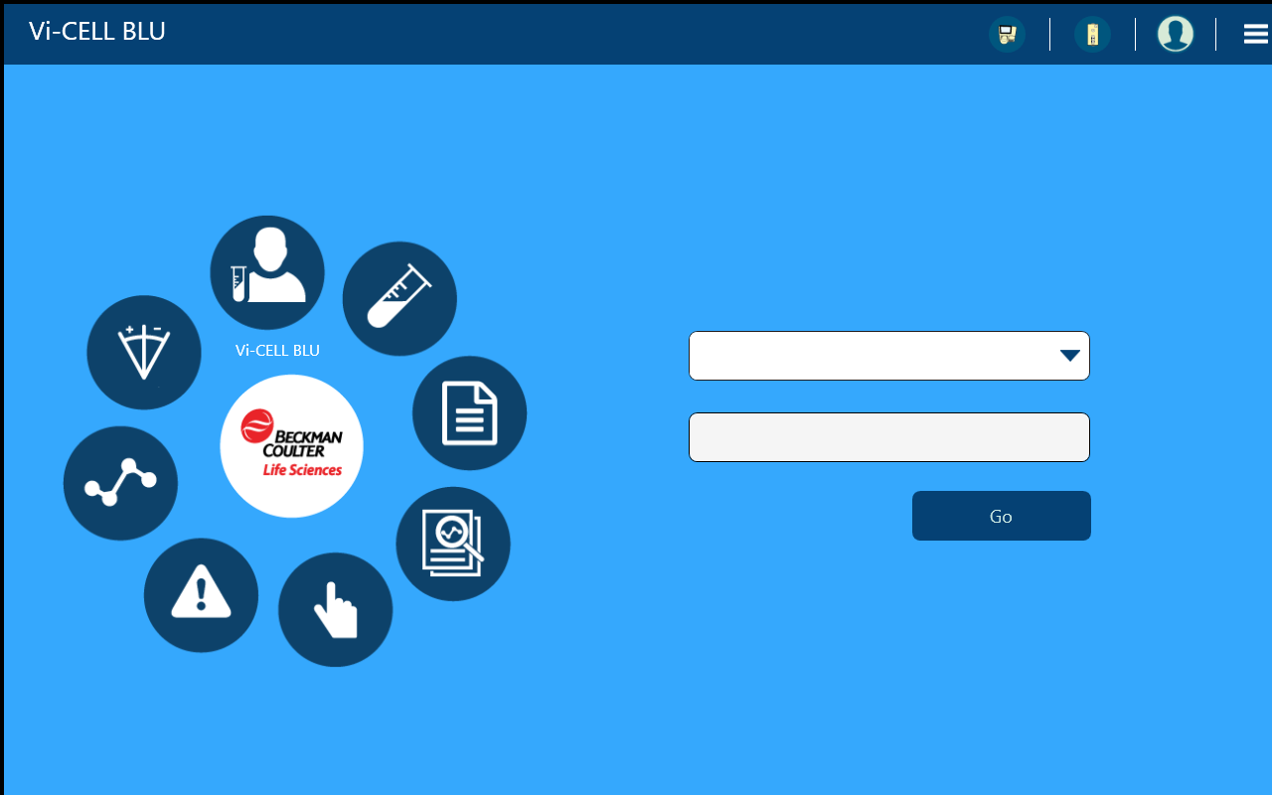

1. If the system boots properly to the UI screen. Exit the UI (using the ‘X’ button on the top bar, if present, or the ALT-F4 key combination to terminate the UI application.
2. Using File Explorer, navigate to the C:\Instrument\Software folder and locate the ‘ViCellUI.exe.config.xxx’ files manipulated in steps 5 and 6 above. Copy the file ‘ViCellUI.exe.config.hdwr’ to the file name ‘ViCellUI.exe.config’ to make it the active UI configuration file. This will configure the UI to start in the presence of instrument hardware, as is the expected condition.
3. The vendor will create and maintain a build procedure for the creation of hard drives using a reference hard drive volume.

## Disk Image creation

1. The created hard drive with the OS image and application set successfully installed may be used for the creation of additional hard drive media.
2. The vendor will create and maintain a build procedure for the creation of hard drives using a reference hard drive volume.
3. The created hard drive may be used to create installation media to be used for system recovery or to return a hard drive to the factory base condition.
4. When recovery media is required, the vendor will create and maintain a build procedure for the creation of recovery/restoration media using a reference hard drive volume.

# Labeling Requirements

**Sample Image for Assembly Packaging Label: (Approximate size 1/2” x 2”)**

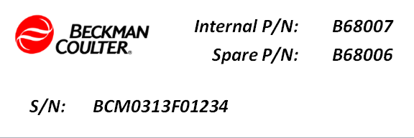

*P/N: C08356*

*Reference: XXXXX*

*S/N: BCI011GF08714*

An example of a combined package label with HIBC barcoding is shown below. Note that the sample uses a different part number and target model number.



**Notes on Assembly Packaging Label modifications:**

The serial number shown on the sample labels is for illustrative purposes only. The reference number is optional, but if provided, should reference the vendor part number. Any included reference number should also appear on the shipping label.

Label may be printed monochrome if color is not available.

**Notes on Packaging Labels:**

The manufacturer need not be identified on the package unless legally required.